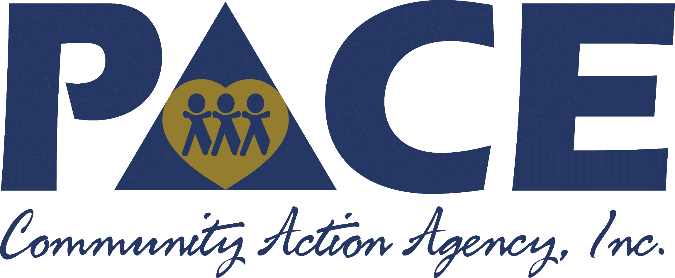
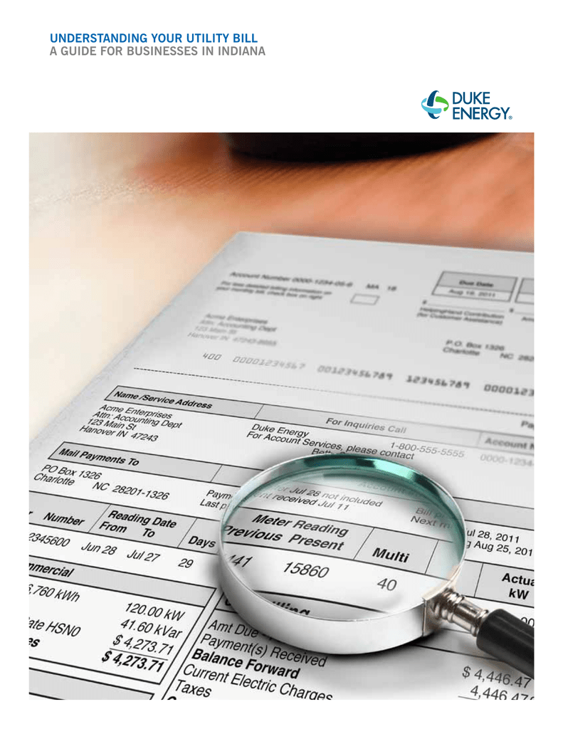
Application Assistance Event

If you need personal assistance completing or reviewing your Energy Assistance Application, you may attend ANY event.

Sullivan County: Daviess County:
Date: October 5, 2023 Date: October 12, 2023
Time: 9:00 am – 3:00 pm Time: 9:00 am – 3:00 pm
Place: Sullivan Civic Center Place: Washington Community Bldg.
344 N Main Street 501 Burkhart Drive
Sullivan, IN 47882 Washington, IN 47501

Greene County: Knox County:
Date: October 19. 2023 Date: October 26, 2023
Time: 9:00 am – 3:00 pm Time: 9:00 am – 3:00 pm
Place: Scout Building Place: Pace CAA
1352 A Street, NE 525 N 4th Street
Linton, IN 47441 Vincennes, IN 47591

*****************************************************************************************
Ongoing In-Person Assistance Opportunities:

Applications will be reviewed and accepted monthly from
10:30 a.m. – 1:30 p.m. beginning Nov. 2, 2023.

Knox County: Daviess County:
Pace CAA Washington Carnegie Library 525 N 4th Street 300 W Main Street
Vincennes, IN 47591 Washington, IN 47501

Dates: 12/5/23, 1/2/24, Dates: 11/21/23, 12/19/23,
2/6/23, 3/5/24, 4/2/24. 1/16/24, 2/20/24, 3/19/24,
4/16/24.
Greene County: Sullivan County:
Linton Public Library Sullivan Co. Public Library
95 1st Street SE 100 S Crowder Street
Linton, IN 47441 Sullivan, IN 47882

Dates: 11/16/23, 12/21/23, Dates: 11/2/23, 12/7/23, 1/4/24
1/18/24, 2/15/24, 3/21/24, 2/1/24, 3/7/24, 4/4/24.
4/18/24.

